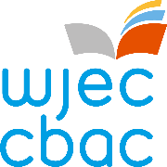

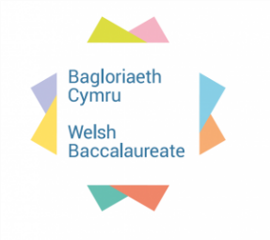

WELSH BACCALAUREATE
SKILLS CHALLENGE CERTIFICATE
National/Foundation

Global Citizenship Challenge
Keep Wales Tidy - Single Use Plastic Packaging

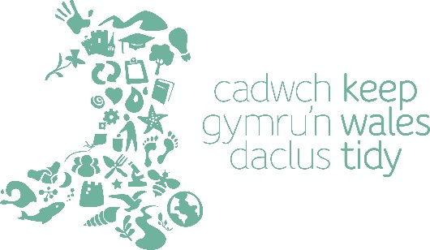

Available for assessment from September 2022

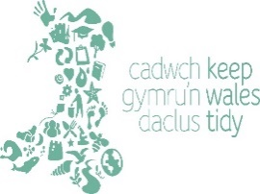
Single Use Plastic Packaging

PURPOSE
The purpose of the Global Citizenship Challenge is to develop learners’ skills, whilst providing opportunities to understand and respond appropriately to global issues. During the Global Citizenship Challenge learners will explicitly develop skills of Critical Thinking and Problem Solving and Creativity and Innovation and apply them in an appropriate manner.

BRIEF
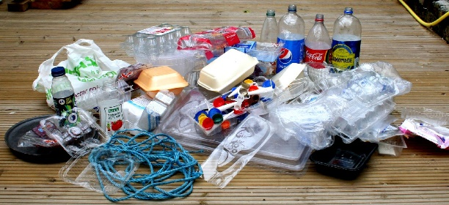
There are many problems in the world that we should all help to resolve even if it happens hundreds or thousands of miles away, or where you live in Wales. How do you become a global citizen? You need to develop a human conscience and make judgments about the issues that matter and the type of world you want to live in. Being a global citizen gives you the power to bring about positive change to make this world a better place.

Keep Wales Tidy is a charity working across Wales to protect our environment for now and for the future. We know a good quality environment matters to people and the benefits can have a big impact on our communities, health and well-being and economy. We take action to make a positive difference and our work ranges far and wide!

You will use a variety of information provided by Keep Wales Tidy to develop and support particular arguments and viewpoints and identify your own ideas on this global issue to construct your own Personal Standpoint on single use packaging.

You then have to Raise Awareness of unnecessary single use plastic packaging, how to change behaviour and reduce our use to single use plastic packaging. Be creative so that it will appeal to the target audience and make use of effective communication by providing a clear message which is memorable, original and relevant.

By completing this Challenge you will show that you can reason, make judgements and make decisions in order to create an informed Personal Standpoint on single use plastic packaging. The raising awareness allows you to show how creative and innovative you can be in communicating your ideas and presenting your message to other people.

Take the Challenge further
If you’d like to take the Challenge further, you can enter your raising awareness pack into an international competition - ‘Young Reporters for the Environment – Litter Less’. This competition raises awareness of litter issues and its detrimental effect on the environment. It encourages young people to propose innovative ideas and solutions to change behaviour. If you take part in the competition, your ideas and solutions to single use plastic packaging will be presented to Keep Wales Tidy’s CEO and other members of the Young Reporters for the Environment jury through your competition entries.

RESOURCES: To access the updated Keep Wales Tidy Resource Pack contact www.keepwalestidy.cymru
CONTACTS: yre@keepwalestidy.cymru

