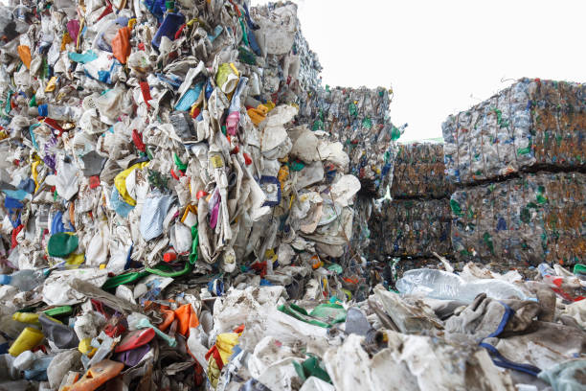
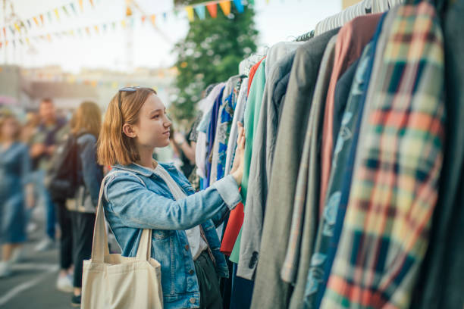
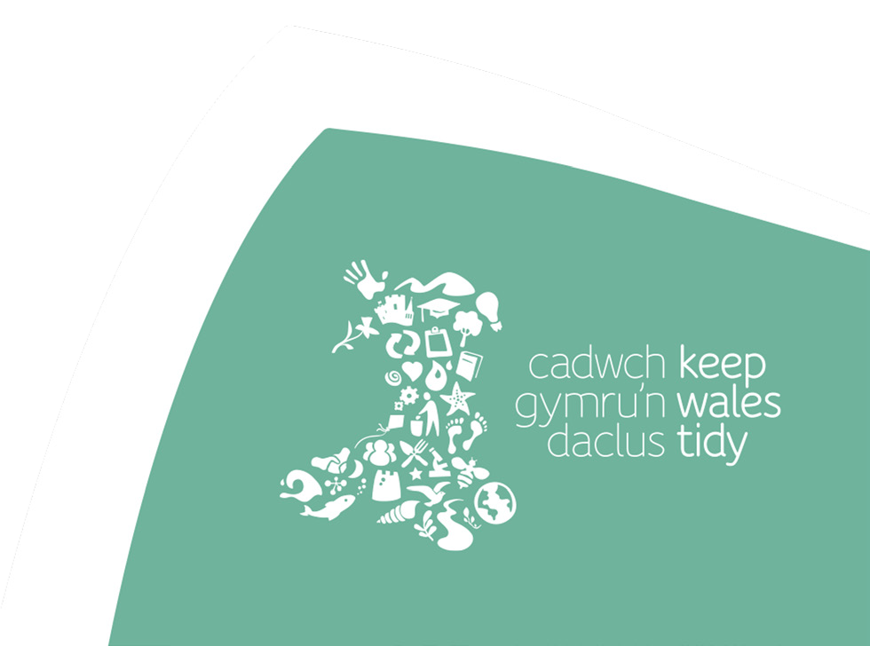
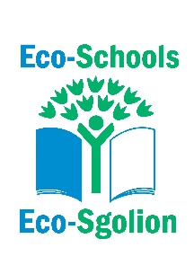
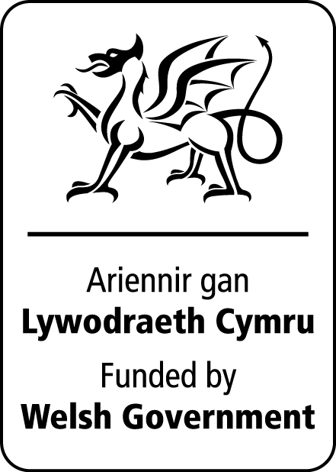
Circular Fashion
Exploring rethinking fashion to make it circular

Curriculum links
Progression Step 4

Purposes: Ethical, informed citizens
Enterprising, creative contributors
Ambitious capable learners

AOLEs and What Matters statements:

Science and Technology
- Design thinking and engineering offer technical and creative ways to meet society’s needs and wants.
- Computation is the foundation for our digital world.

Humanities
- Enquiry, exploration and investigation inspire curiosity about the world, its past, present and future.
- Our natural world is diverse and dynamic, influenced by processes and human actions.
- Informed, self-aware citizens engage with the challenges and opportunities that face humanity and are able to take considered and ethical action.

Health and Well-being
- Our decision-making impacts on the quality of our lives and the lives of others.
- How we engage with social influences shapes who we are and affects our health and well-being.

Expressive Arts
- Responding and reflecting, both as artist and audience, is a fundamental part of learning in the expressive arts.

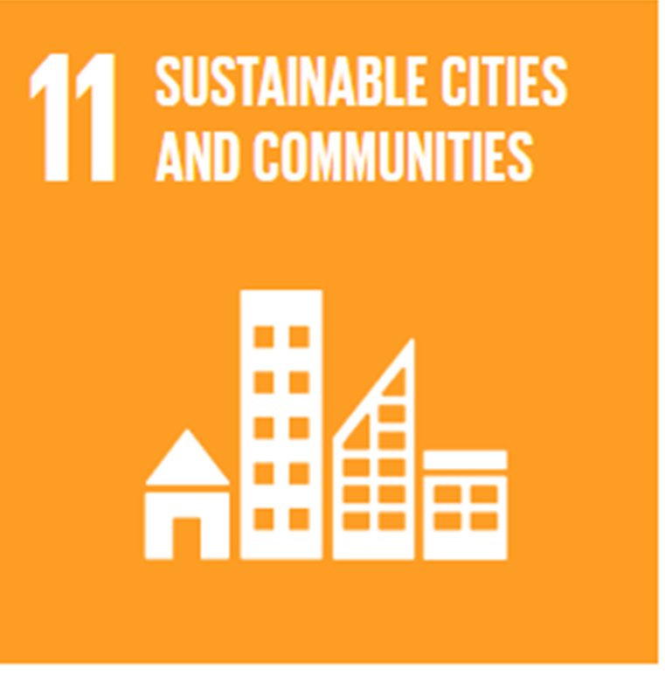
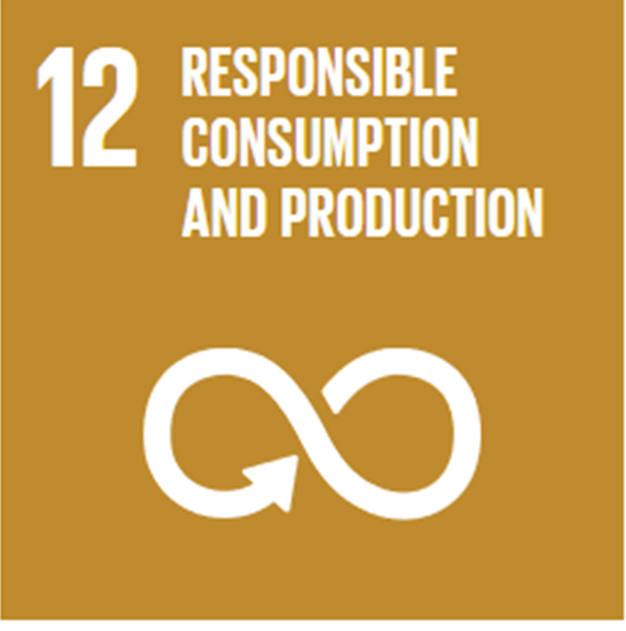
Global Goals

Activity

Materials needed:
Circular Fashion presentation
Internet access (for individual or pairs)

- Watch the Make Fashion Circular video (2.03 mins, slide 2)
- Talk through and discuss the Fast Fashion facts (slides 3 – 5)
- Ask the learners to think of brands/organisations that they believe are circular, or sustainable. Then, go through the selection given (information about each company is in the presentation notes). Please note - this is just a small selection of circular brands/organisations. There are others out there; for example, H&M have some sustainable lines.

- Ask the learners to research these brands/organisations, and others they may find, to get inspiration for their own circular fashion brand/organisation which they will now create.

- The Learners are to design their own fashion brand or organisation (through mind maps, drawings, plans, mood boards, social media etc.). Encourage them to consider –

- Name, logo, strapline etc.
- Story – many sustainable brands have a great story behind them
- What is your product and why? How is it being sold/used?
- Where is it made, what materials are used?
- What makes it sustainable and circular?
- How can it help the planet?
- Packaging, care, end of life choices?
- Anything else that is important people know about your brand

- Present the designs to the class who will give constructive feedback

Reflections

Consider all that you have learnt out circular fashion, what changes could you make to the way you buy and dispose of your clothing?

What barriers might some people feel there to shopping in a more sustainable way, how could these be overcome?


33-35 Heol yr Eglwys Gadeiriol, Caerdydd, CF11 9HB | 33-35 Cathedral Rd, Cardiff, CF11 9HB
029 2025 6767 keepwalestidy.cymru info@keepwalestidy.cymru
Cadwch Gymru’n Daclus yn gwmni wedi ei gyfyngu trwy warant. Rhif Cwmni: 4011164 Rhif Elusen: 1082058 Rhif TAW: 850 3958 13
Keep Wales Tidy is a Company Limited by Guarantee. Company Registration Number: 4011164 Charity Registration Number: 1082058 VAT Registration Number: 850 3958 13

