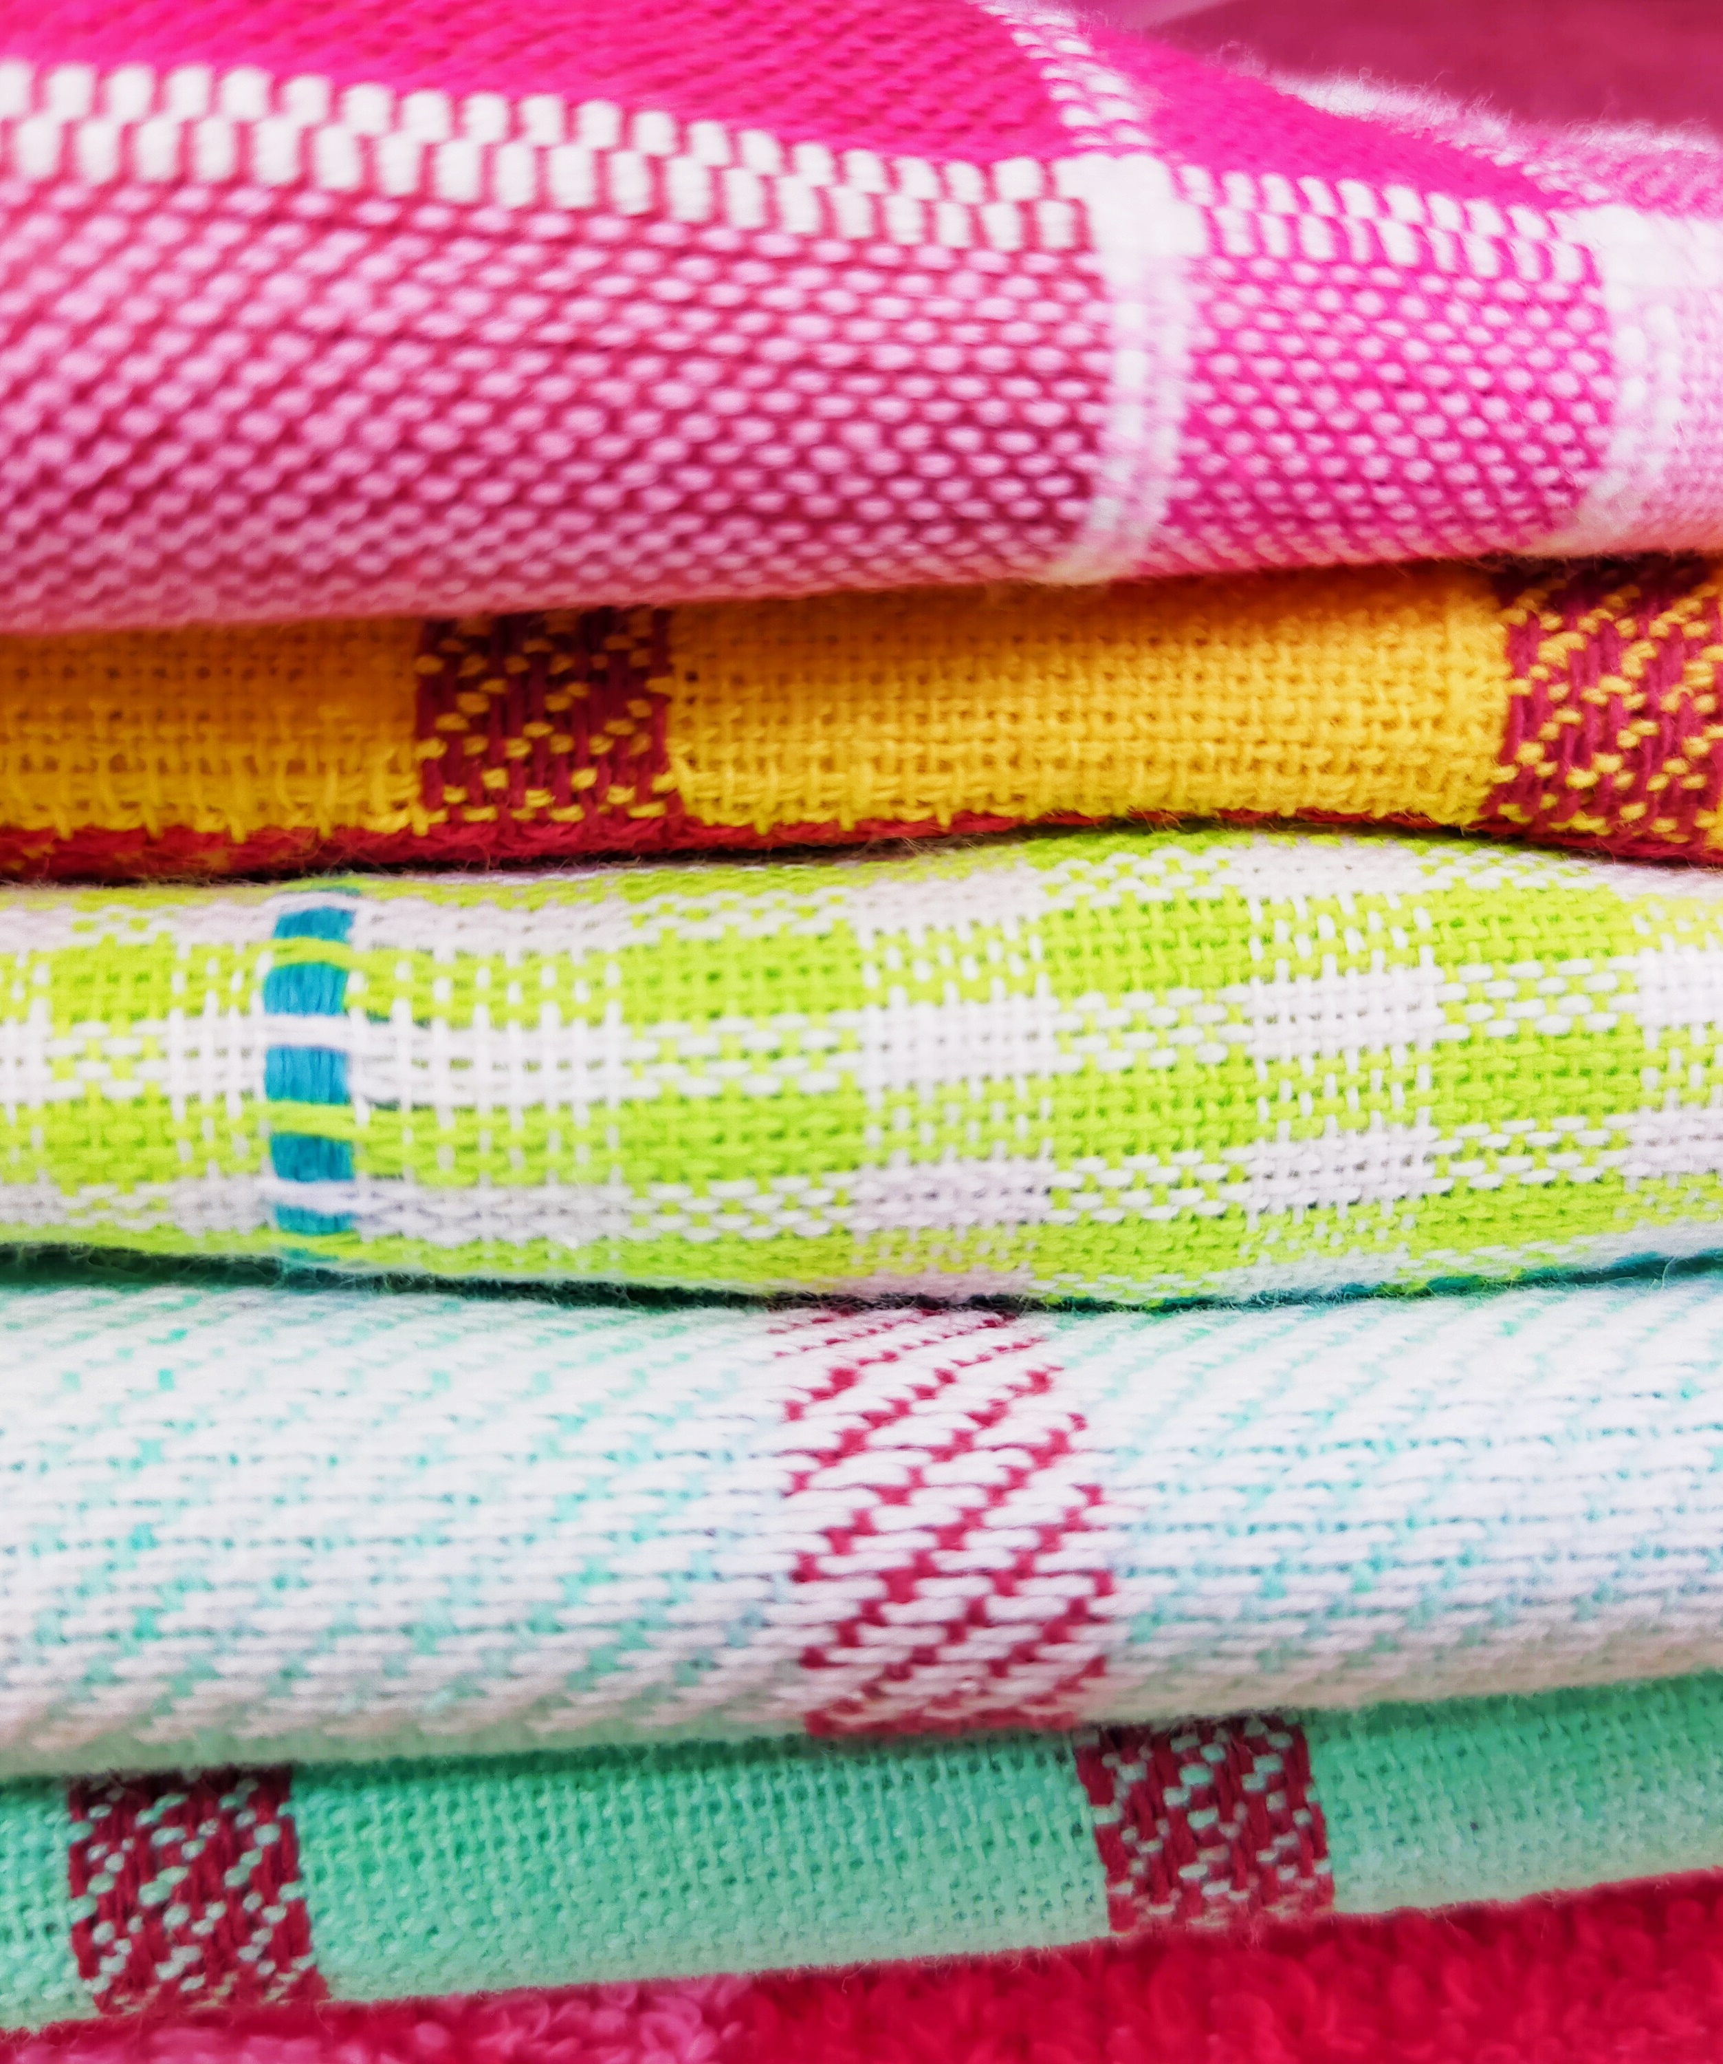
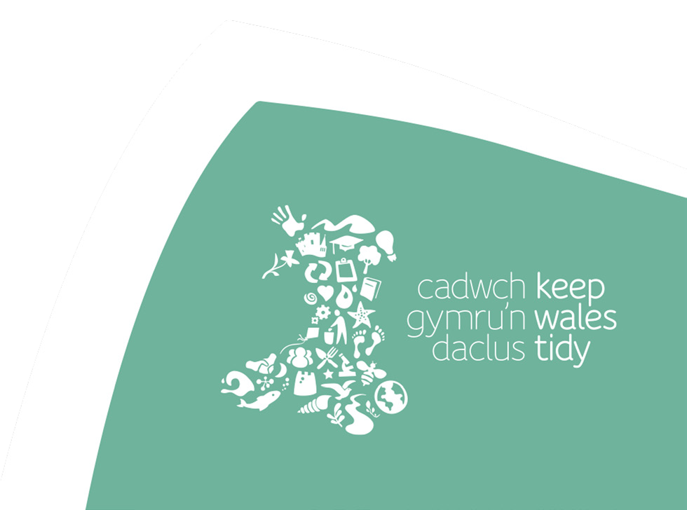
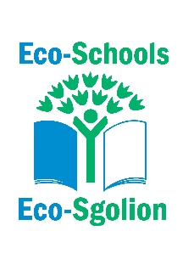
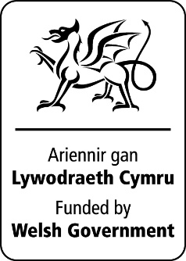
Material Impact
A look at the impact materials used in the fashion industry have on the environment

Curriculum links
Progression Step 4
Purposes: Ethical, informed citizens
Ambitious capable learners

AOLEs and What Matters statements:

Humanities
- Enquiry, exploration and investigation inspire curiosity about the world, its past, present and future.
- Informed, self-aware citizens engage with the challenges and opportunities that face humanity and are able to take considered and ethical action.

Health and Well-being
- Our decision-making impacts on the quality of our lives and the lives of others.

Science and Technology
- Being curious and searching for answers is essential to understanding and predicting phenomena
- The world is full of living things which depend on each other for survival
- Matter and the way it behaves defines our universe and shapes our lives

Global Goals
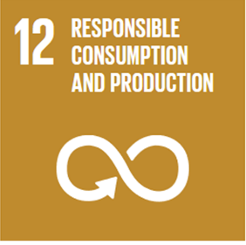
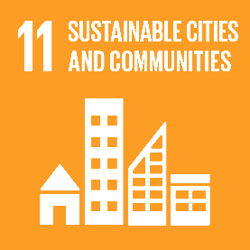
Activity

Materials needed:
Material Impact presentation
Material diamond ranking worksheet
Dimond ranking cards (optional)
Research material/presentation
Access to the internet (optional)

- Ask learners what materials they think t-shirts are made from create a list. Look at the list of the 9 material provided how do they compare?

- Rank the list of 9 material provided this could be physical cards (template slide X). Learners can add their rank to the worksheet and justify their selection using any initial thoughts, previous knowledge.

- Ask the learners to then research the materials and complete the table on the worksheet exclude the final column at this stage. This could be online or using the presentation provided or a combination. If using ICT ask learners to consider the reliability or any bias in the sites they use.

- After the research has been carried out learners complete the final column to indicate if overall, they think the material generally has a positive (+ve) or negative (-ve) impact or colour code.

- Watch the video clip The life cycle of a t-shirt - Angel Chang - YouTube (Slide) Ask learners to draw and annotate a diagram showing the life cycle of a T-shirt.

- Ask learners to revisit their diamond ranking and use the information they gathered in the research to justify why they have or have not re-ranked the materials. Learners can then share the ranking with the class to see if they can come to a consensus of the top 3 materials that have the minimum impact on the environment.

Reflections

What materials should people be looking for if they need to buy new clothes?

What can we impact the choices manufacturers make when producing clothing?

Fast Fashion: What is Your T-Shirt Made From? Name: Date:
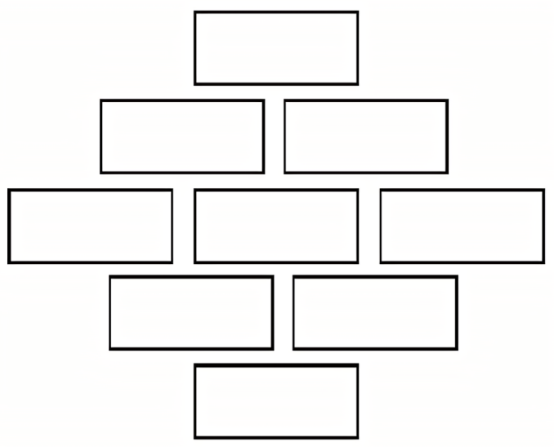  Diamond Ranking: |  |  | Justification:
Material | Water | Energy | Pollution and chemicals | GMO and Soil | Waste/Renewable/  Biodegradable | Other notes | Overall Impact +ve/-ve
Polyester

Recycled Polyester
Hemp

Organic Cotton

Cotton

Merino wool

Bamboo

Orange fibres

Synthetic fibres e.g. spandex, lycra, nylon
Diamond Ranking; |  |  | Justification: Have you changed your diamond ranking? Why/Why not?


33-35 Heol yr Eglwys Gadeiriol, Caerdydd, CF11 9HB | 33-35 Cathedral Rd, Cardiff, CF11 9HB
029 2025 6767 keepwalestidy.cymru info@keepwalestidy.cymru
Cadwch Gymru’n Daclus yn gwmni wedi ei gyfyngu trwy warant. Rhif Cwmni: 4011164 Rhif Elusen: 1082058 Rhif TAW: 850 3958 13
Keep Wales Tidy is a Company Limited by Guarantee. Company Registration Number: 4011164 Charity Registration Number: 1082058 VAT Registration Number: 850 3958 13






