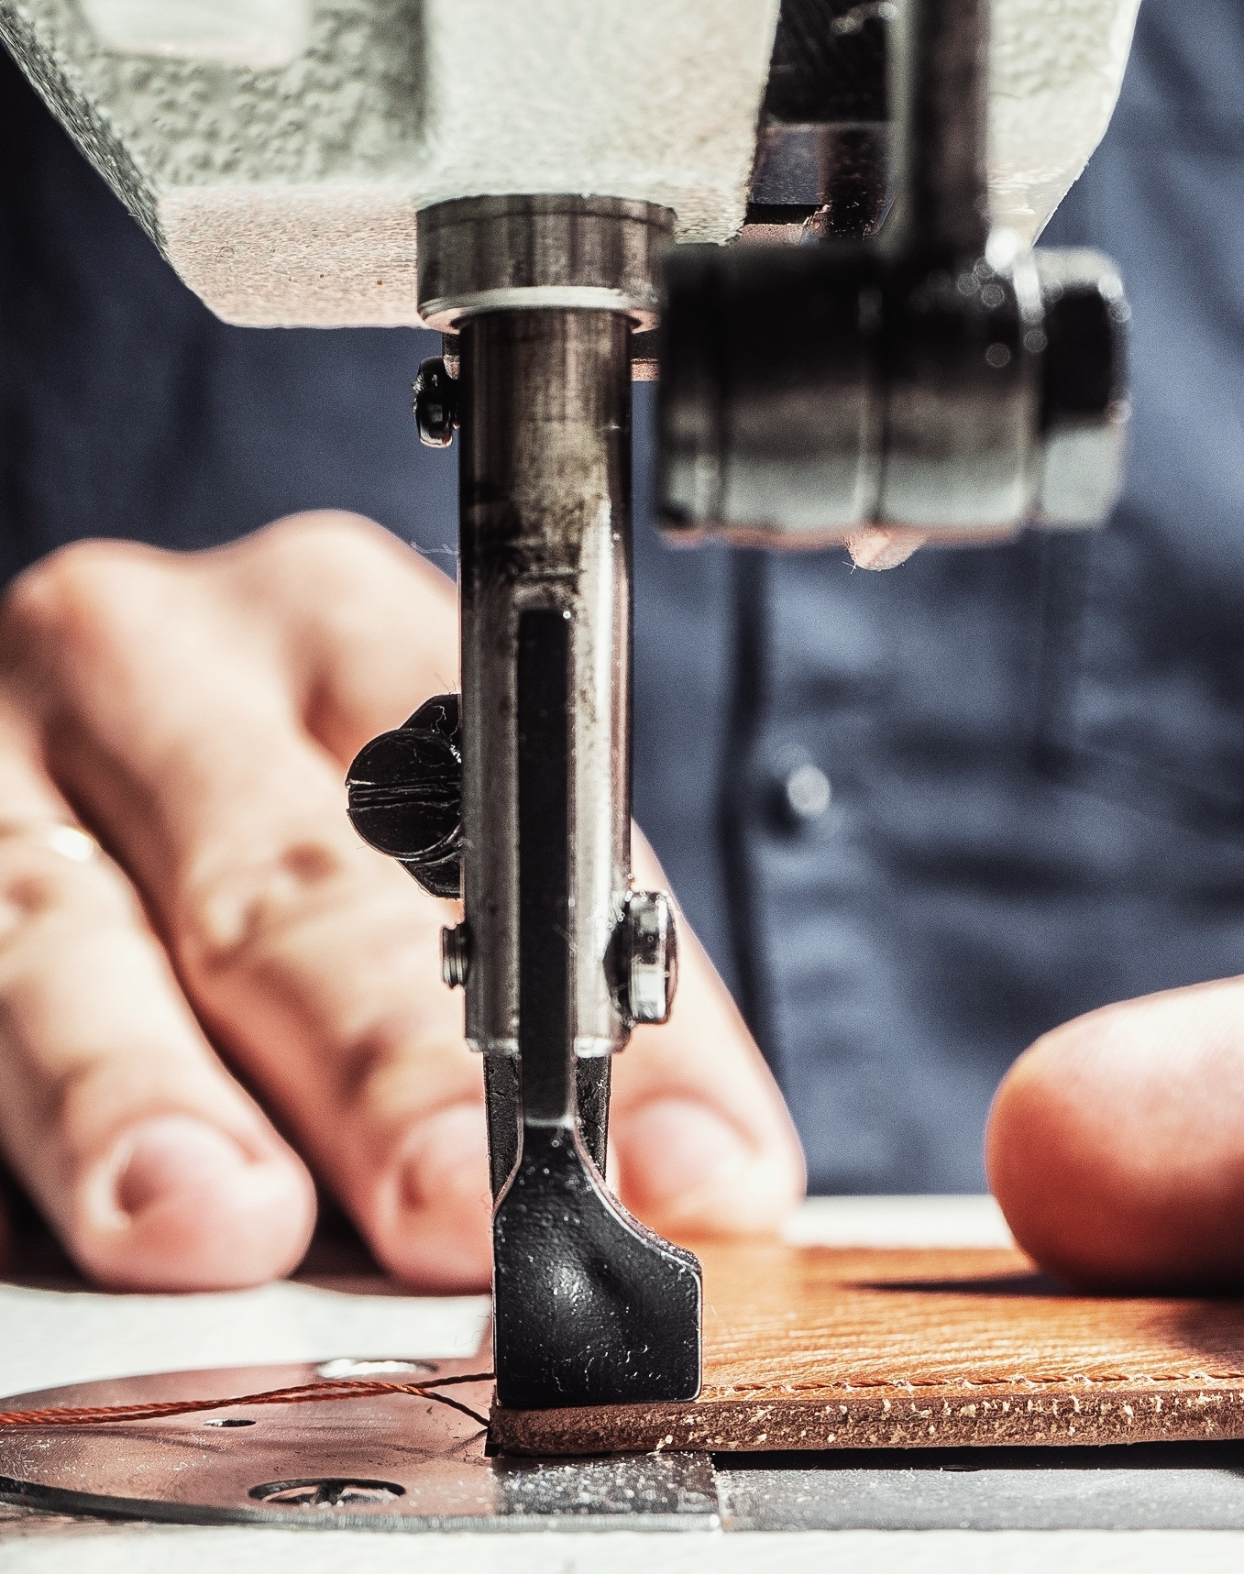
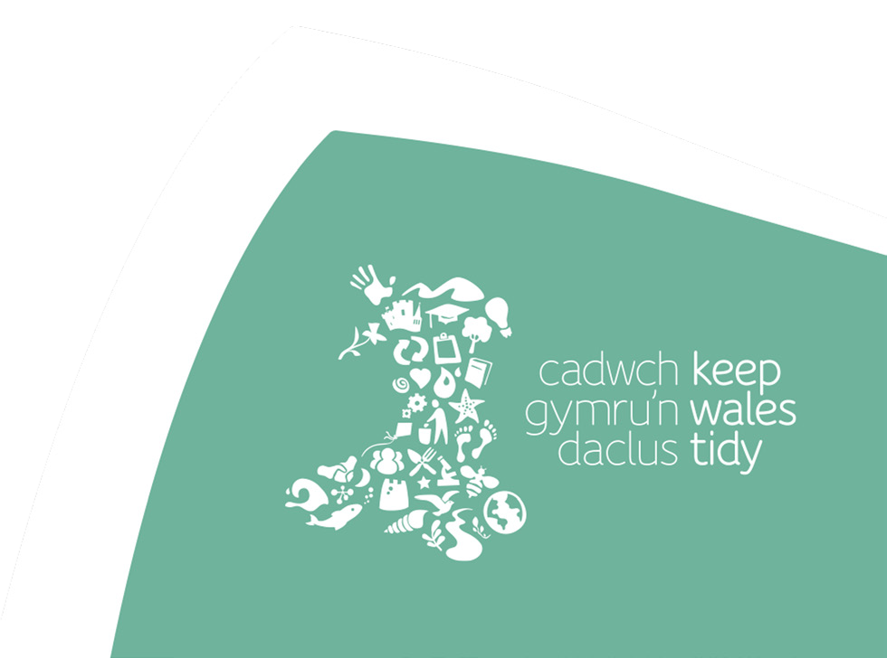
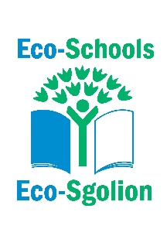
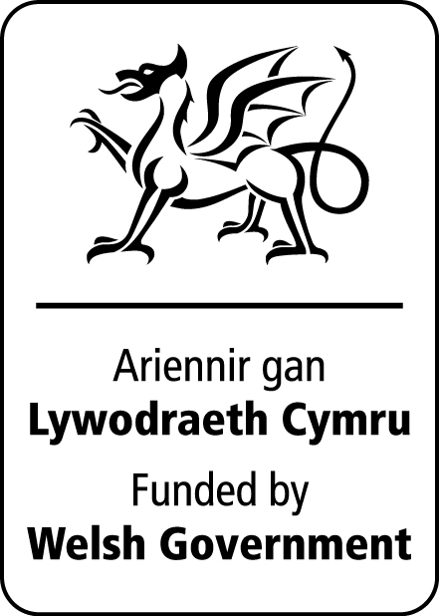
Social Justice
A look at the fashion supply chain helping to understand who makes your clothes.

Curriculum links
Progression Step 4
Purposes: Ethical, informed citizens
Ambitious capable learners

AOLEs and What Matters statements:

Humanities
- Enquiry, exploration, and investigation inspire curiosity about the world, its past, present, and future.
- Our natural world is diverse and dynamic, influenced by processes and human actions.
- Informed, self-aware citizens engage with the challenges and opportunities that face humanity and are able to take considered and ethical action.

Health and Well-being
- Our decision-making impacts on the quality of our lives and the lives of others.
- How we engage with social influences shapes who we are and affects our health and well-being.

Expressive Arts
- Events and human experiences are complex, and are perceived, interpreted, and represented in different ways.
- Human societies are complex and diverse, and shaped by human actions and beliefs.
- Informed and self-aware citizens engage with the challenges and opportunities that face humanity, and are able to take considered and ethical action.

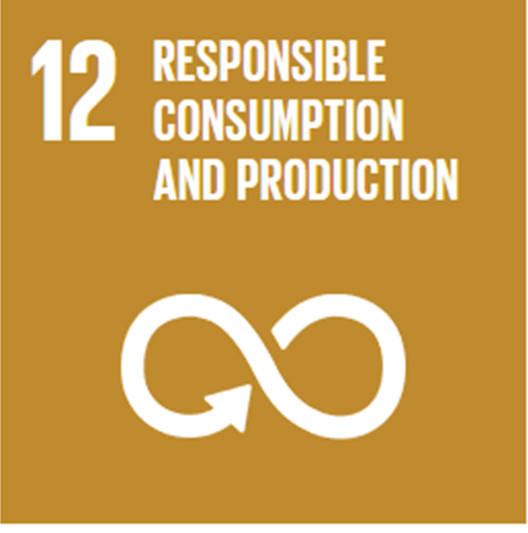
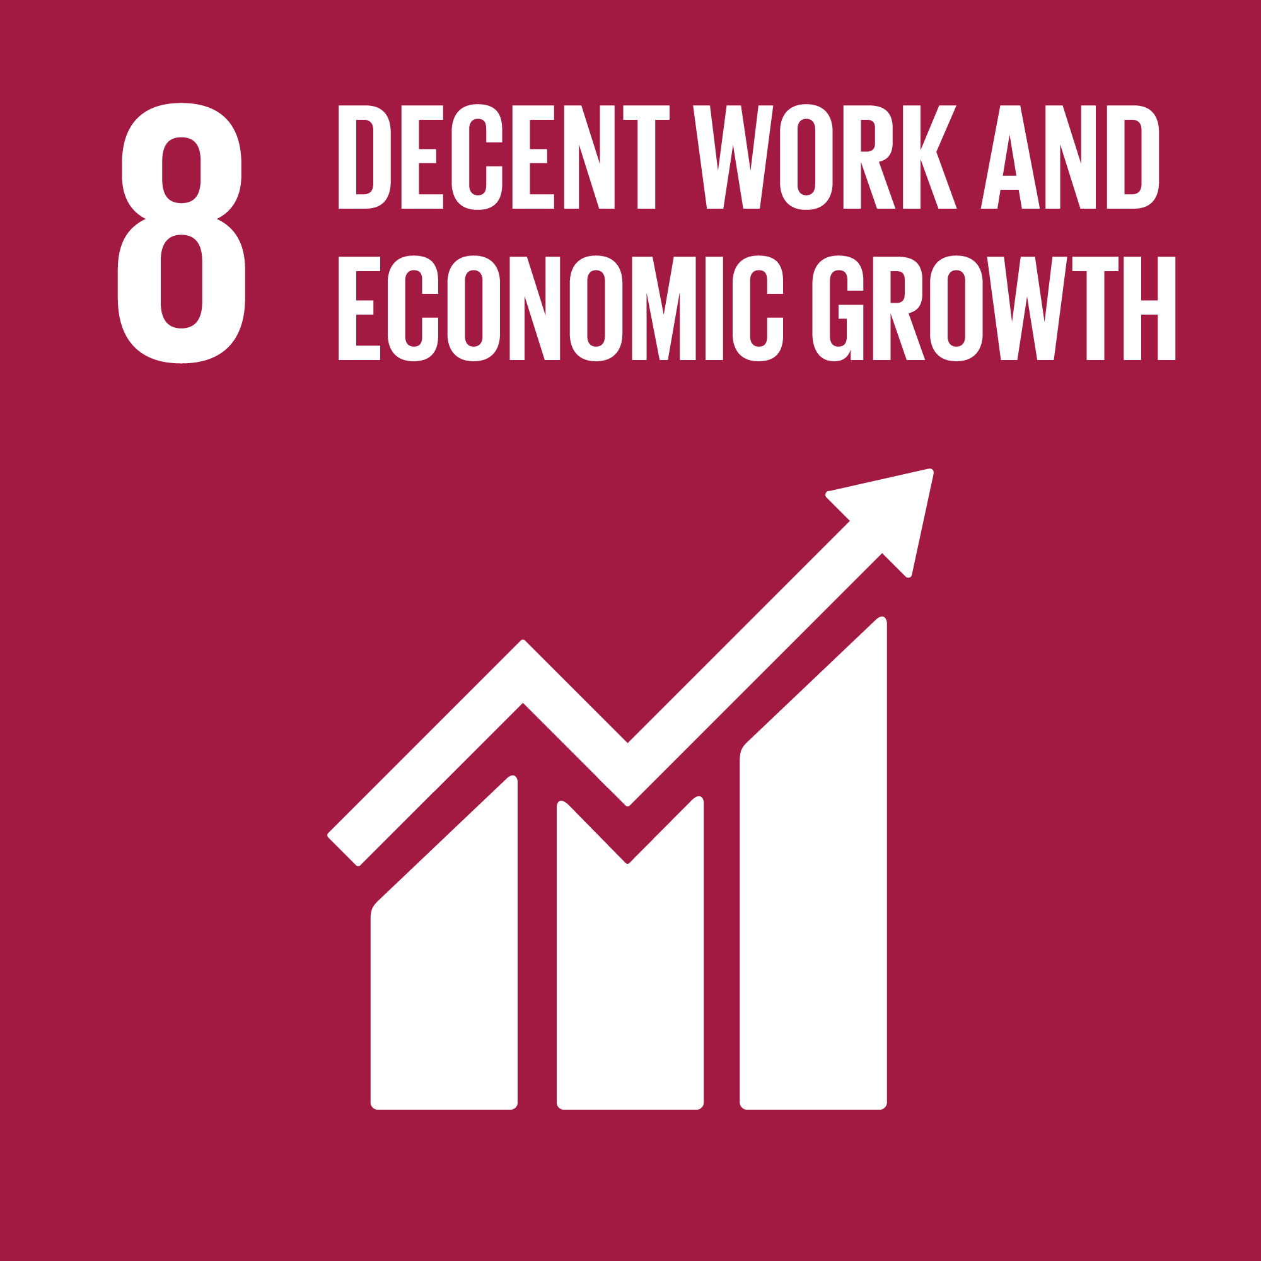
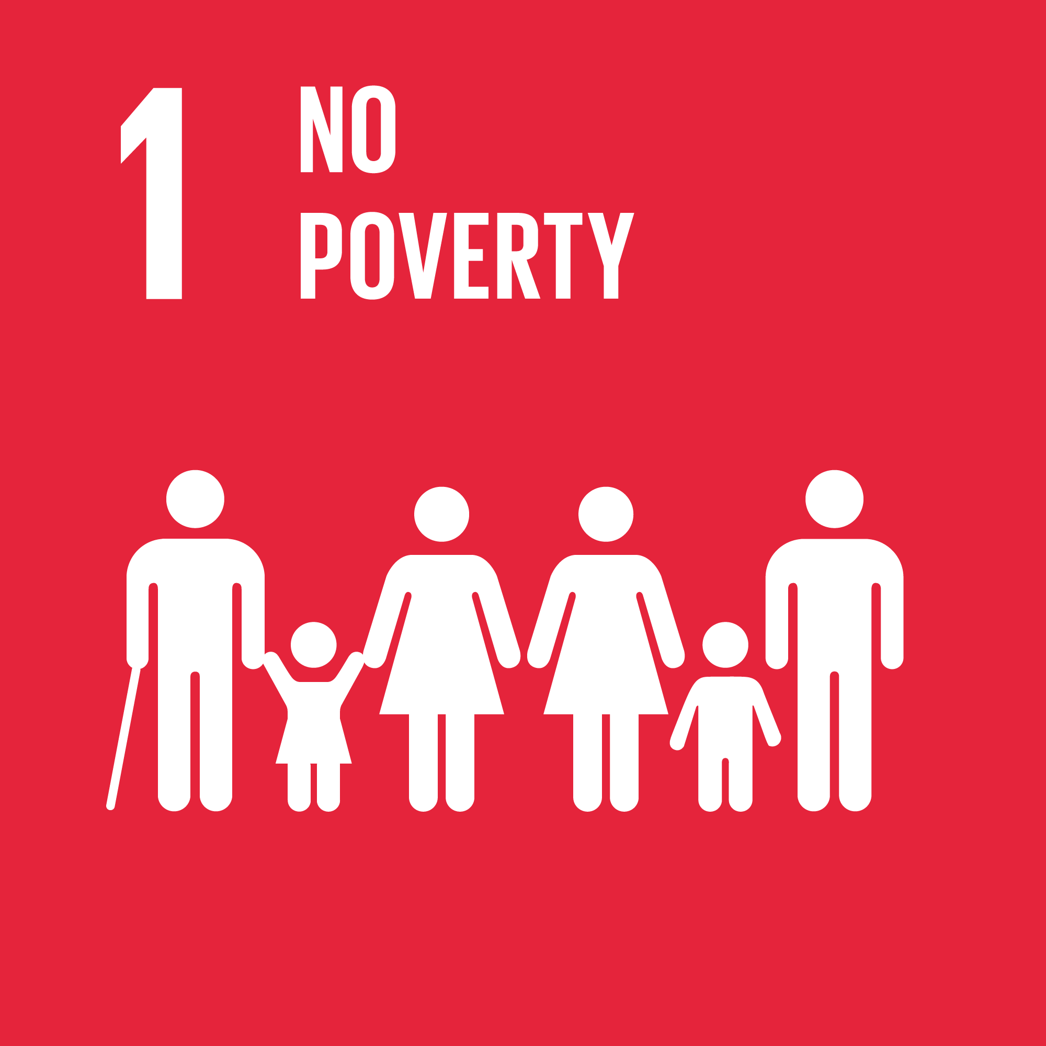
Global Goals

Activity

Materials needed:
Social Justice presentation
Quiz worksheet
Inference grid Worksheet
Stakeholder – Talking heads Worksheet
Access to the internet (optional)

- Carry out the quiz worksheet, alternatively it could be carried out as a continuum activity as a class.

- Discuss how learners feel about the statements. Use the facts in the presentation to build the discussion.

- Ask the learners to look at labels on clothing and using general knowledge to make a list of where clothing is made. You could also use a map to locate the countries.

- Ask the learners to consider why clothes aren’t made in the UK and what are the consequences of this? – collate the responses.

- Watch the video clip BBC Three - Blood, Sweat and T-Shirts, Episode 1, Blood, sweat and T-shirts (slide 24)

or read Bangladesh factory collapse: police detain owners, as death toll exceeds 350 | Bangladesh | The Guardian

View the image (slide 26) and complete the inference grid worksheet – use this to support class discussions.

- Divide the learners into stakeholder groups linked to the fast fashion industry. Ask the learners to summarise the viewpoint of fashion from that stakeholder perspective. Leaners could carry out extra research to fully inform their viewpoint. They can share their viewpoints and use the worksheet (Slide 27) to have a collation of all viewpoints.

Reflections

Consider all that you have learnt about who makes your T-shirt and clothing
How can we make a difference to this?

What barriers might some people feel there to shopping in a more sustainable way, how could these be overcome?

How do the following statements make you feel?

Use the bipolar scale to show how much you agree or disagree with the statement.
-2 I’m really not ok with this
+2 I’m totally fine with this

 |  | -2 | -1 | 0 | +1 | +2
1 | It takes 2,700 litres of water to grow the cotton needed for a T-shirt
2 | An estimated £140 million worth (350,000 tonnes) of used clothing goes to landfill every year in the UK
3 | 20% of the water lost from the Aral Sea was caused by cotton consumption in the EU
4 | In Cambodia the fashion industry has caused approximately 60% of the countries water pollution
5 | People who make clothing abroad should be paid a local living wage
6 | People who stich the clothing being paid below local minimum living wage only happens overseas
7 | It’s ok for big brands to say they don’t know what happens to workers and the environment in their supply chain
8 | It’s ok for a plain adult T-shirt to cost £1.50 in the UK
9 | It’s ok to have clothes that will never be worn
10 | Child labour has a place in the fashion supply chain



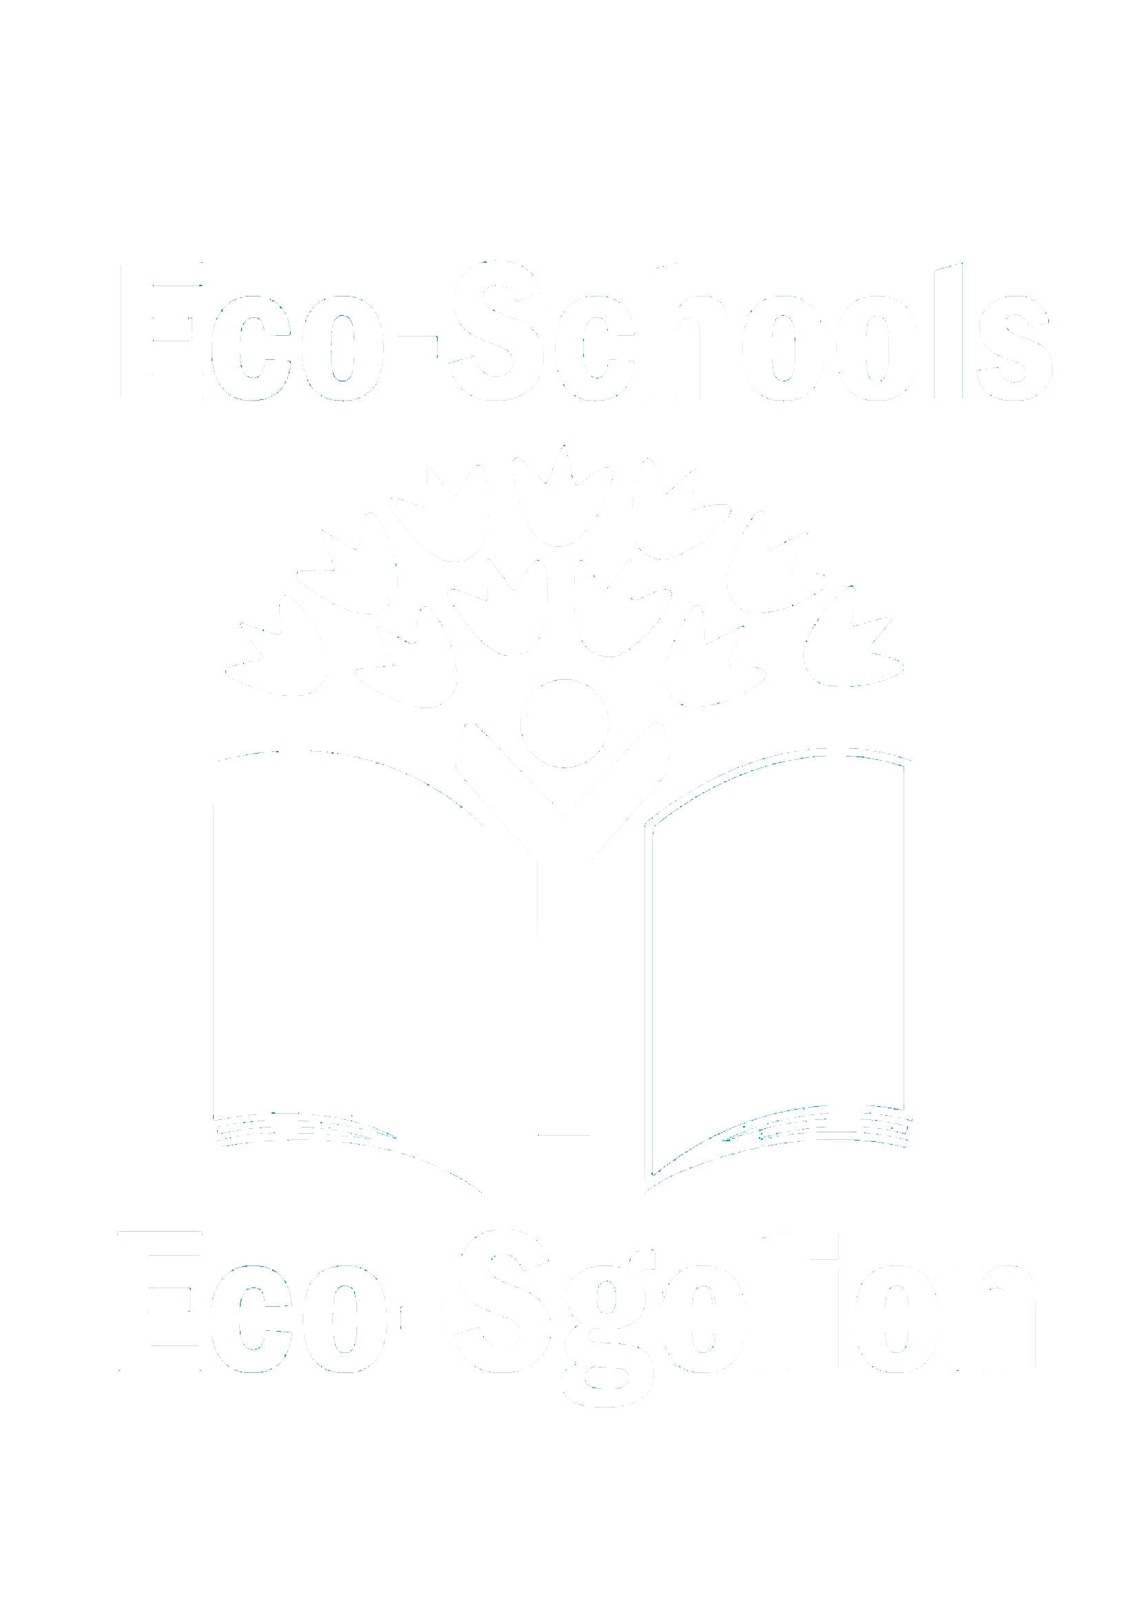


33-35 Heol yr Eglwys Gadeiriol, Caerdydd, CF11 9HB | 33-35 Cathedral Rd, Cardiff, CF11 9HB
029 2025 6767 keepwalestidy.cymru info@keepwalestidy.cymru
Cadwch Gymru’n Daclus yn gwmni wedi ei gyfyngu trwy warant. Rhif Cwmni: 4011164 Rhif Elusen: 1082058 Rhif TAW: 850 3958 13
Keep Wales Tidy is a Company Limited by Guarantee. Company Registration Number: 4011164 Charity Registration Number: 1082058 VAT Registration Number: 850 3958 13

