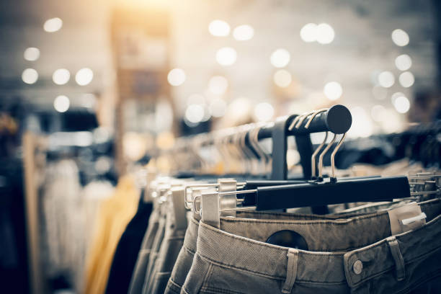
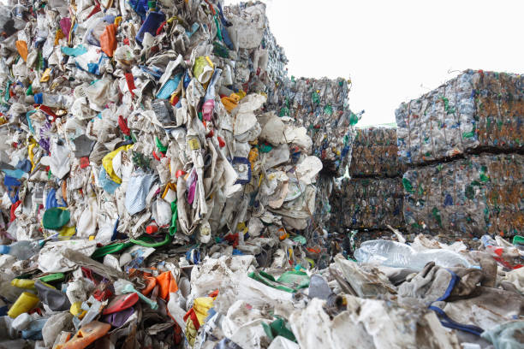
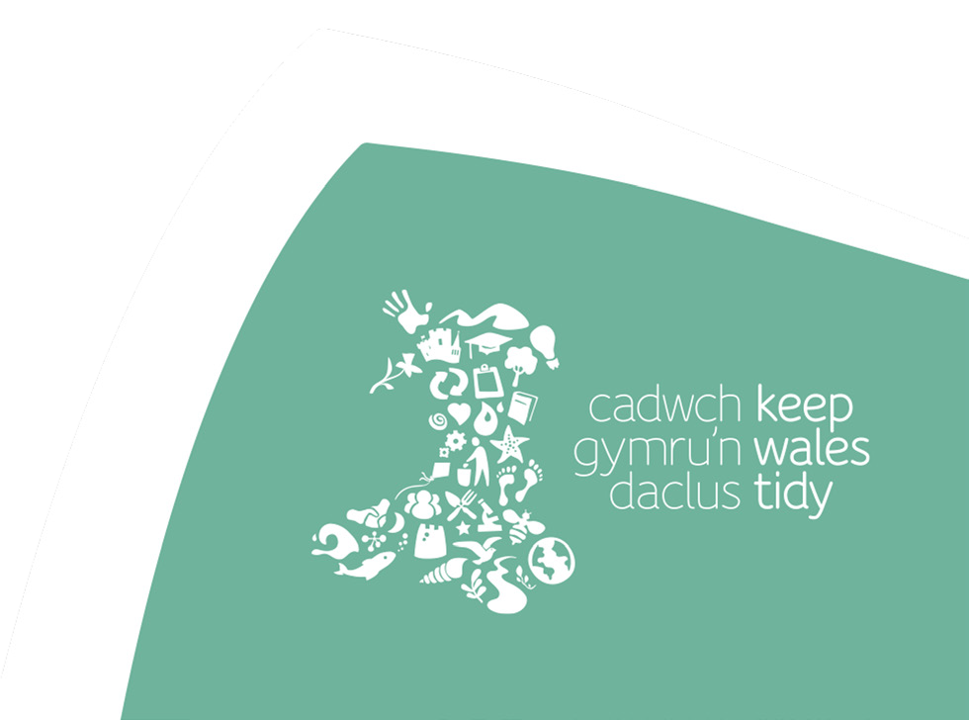
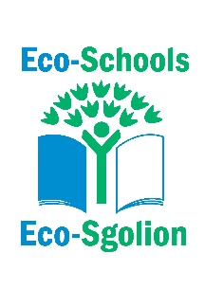
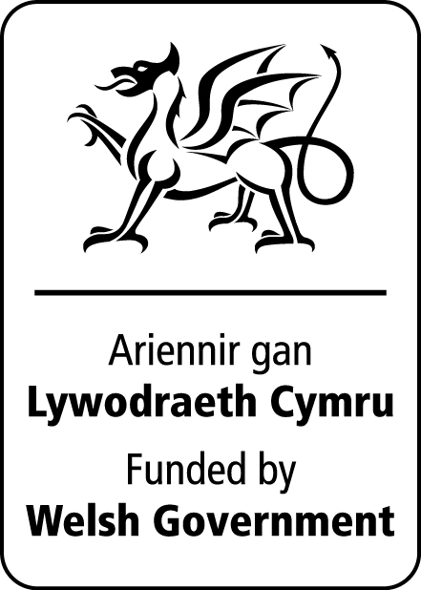

Developing an understanding of what fast fashion is and how It impacts on our planet

Understanding Fast Fashion

Curriculum Links
Progression Step 4

Purposes: Ethical, informed citizens
Ambitious capable learners

AOLEs and What Matters statements:

Science and Technology
- Being curious and searching for answers is essential to understanding and predicting phenomena.
- Design thinking and engineering offer technical and creative ways to meet society’s needs and wants.

Humanities
- Enquiry, exploration and investigation inspire curiosity about the world, its past, present and future.
- Our natural world is diverse and dynamic, influenced by processes and human actions.
- Informed, self-aware citizens engage with the challenges and opportunities that face humanity and are able to take considered and ethical action.

Health and Well-being
- Our decision-making impacts on the quality of our lives and the lives of others.
- How we engage with social influences shapes who we are and affects our health and well-being.

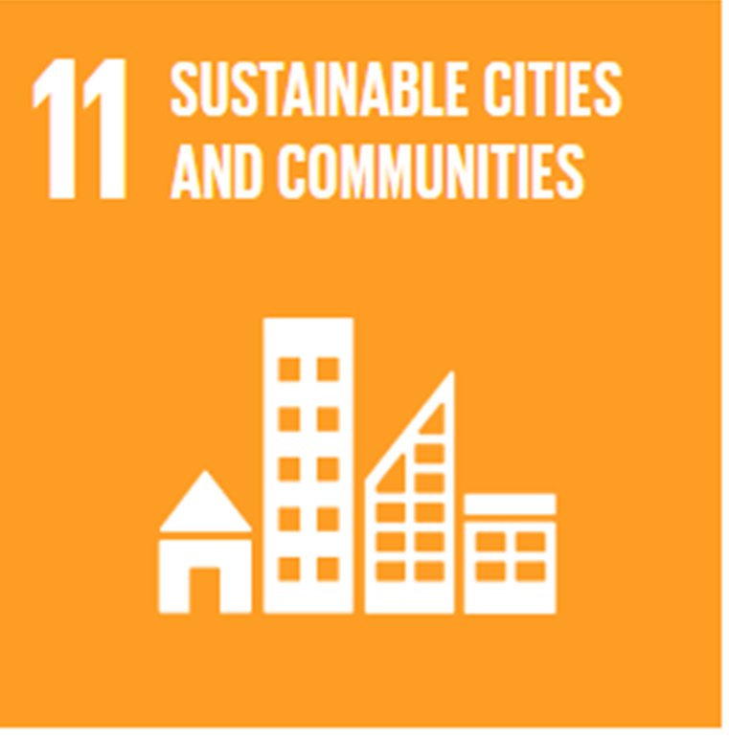
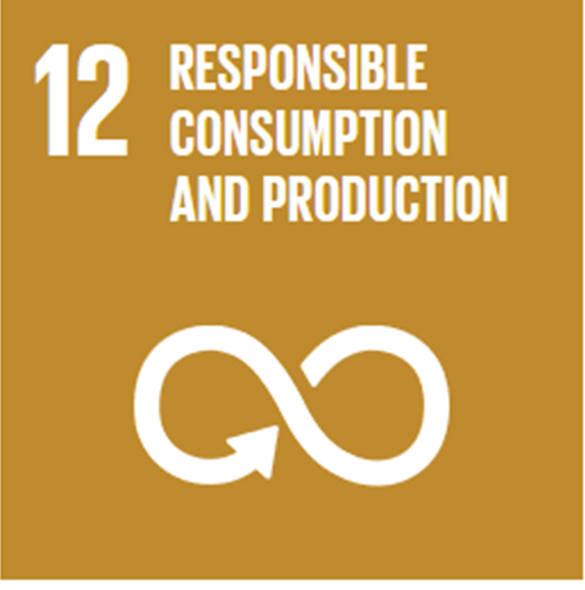
Global Goals

Activity

Materials needed:
Understanding Fast Fashion presentation
The T-Shirt Investigation worksheet
Internet access (for individual or pairs)

1. Ask the class what they think is meant by the term ‘fast fashion’ and discuss the definition on slide

2. Watch the VIDEO - What is Fast Fashion? (3.42 mins, slide 3)

3. Follow this up with some of the facts from the presentation and ask them to share/discuss their thoughts.

4. Using the T-Shirt Investigation worksheet, the students (individually or in pairs) are to carry out online research into 4 different ‘types’ of t-shirts.
- The Cheap One – as cheap as they can find (-£20)
- The Expensive One – as expensive as they can find (£40+)
- The wanted One – a t-shirt that they want to buy
- The Sustainable One – from a sustainable brand such as Patagonia or Rapanui
Use the questions on slide 6 to guide them

Reflection

Feedback thoughts on fast fashion issues and how they feel about clothes buying following this exercise. Consider what changes they and others could make (such as buy from sustainable brands, buying vintage and second-hand clothing, swap shops etc.).

The T-Shirt Investigation
Using the internet, find a t-shirt to fit each of the 4 types in the table and complete as information on each item as possible.
T-SHIRT | Retailer | Cost | Delivery time and cost | Where is it  made? | Where is it being sent from? | Materials | Care Instructions | Eco Credentials
The Cheap
One
The Expensive One
The Wanted
One
The Sustainable
One


33-35 Heol yr Eglwys Gadeiriol, Caerdydd, CF11 9HB | 33-35 Cathedral Rd, Cardiff, CF11 9HB
029 2025 6767 keepwalestidy.cymru info@keepwalestidy.cymru
Cadwch Gymru’n Daclus yn gwmni wedi ei gyfyngu trwy warant. Rhif Cwmni: 4011164 Rhif Elusen: 1082058 Rhif TAW: 850 3958 13
Keep Wales Tidy is a Company Limited by Guarantee. Company Registration Number: 4011164 Charity Registration Number: 1082058 VAT Registration Number: 850 3958 13






