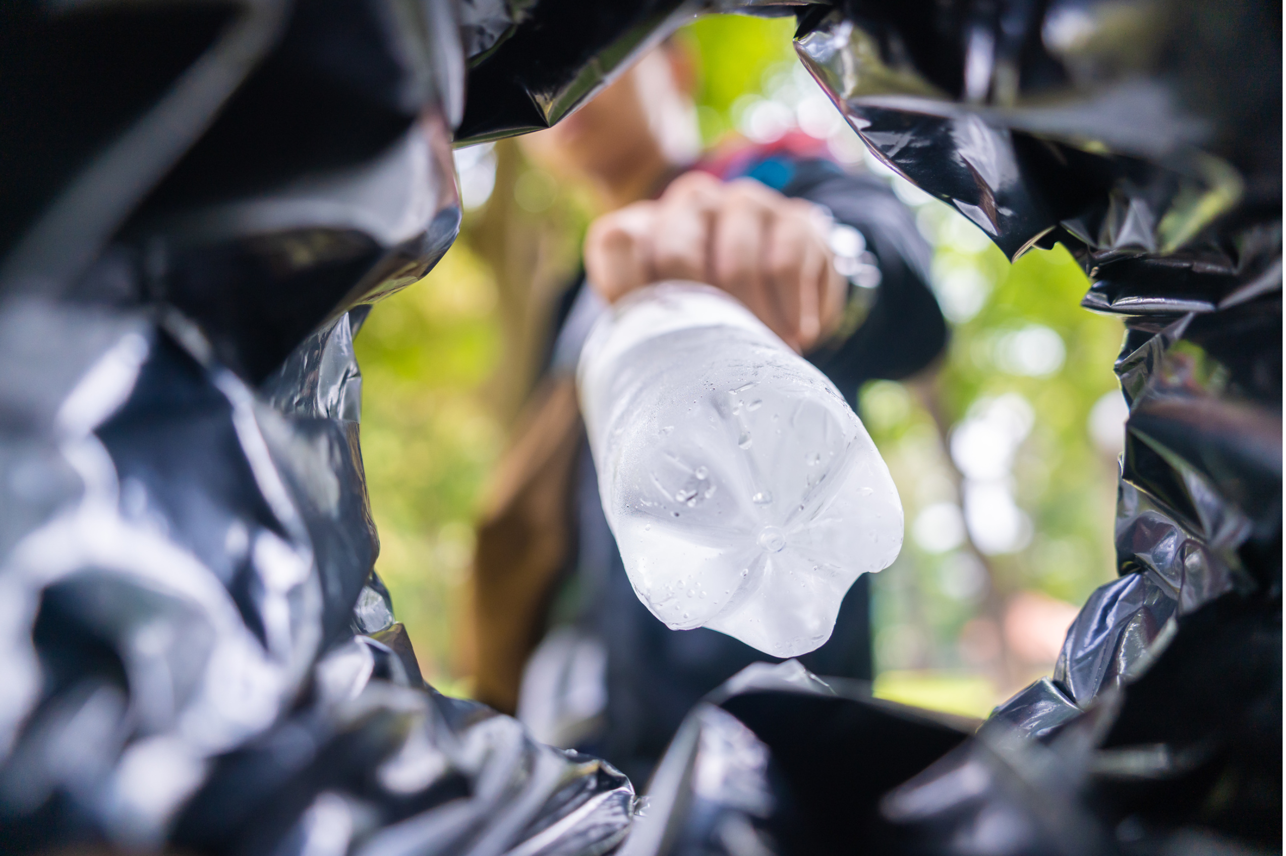
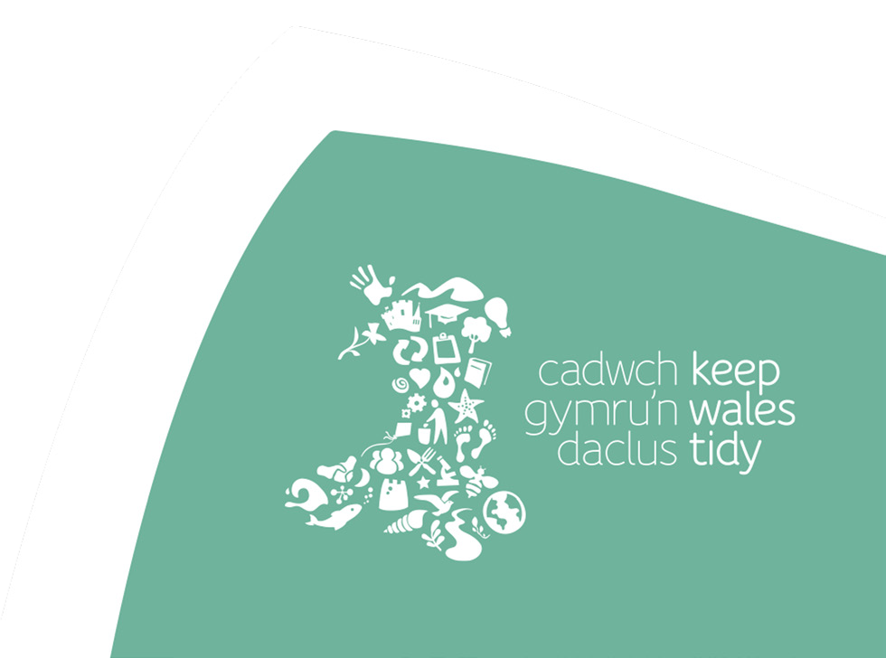
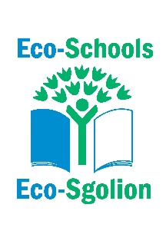
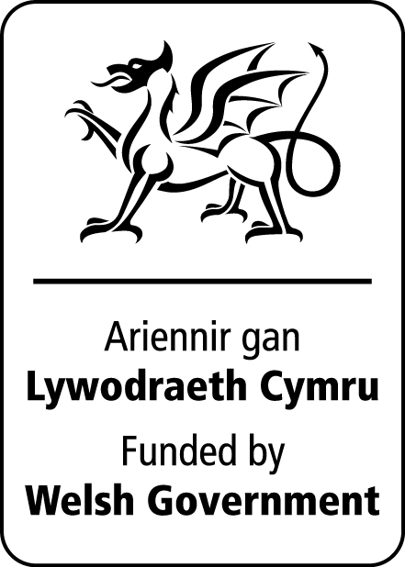
Exploring our waste -
do we really need it and how can we make it circular.

What’s in your bin?
Background Information

Waste is a HUGE problem.

In the UK alone around 6.1 million tonnes of waste goes to landfill each year. Which basically means its buried in a hole in the ground and can take anywhere from 2 weeks to over 200 years to decompose. It is vital we all take responsibility for this because the landfill process is a major source of pollution and contributes to climate change.

- Over 7 million tons of food and drink are thrown away each year. It is estimates that over 50% of the ‘rubbish’ in our bins could be reused or recycled instead.

- On average a typical family will throw away around 40kg of plastic that could be recycled each year

- Approximately 1.65 million tonnes of electricals are sold in the UK each year, with 155,000 tonnes dumped in domestic bins and subsequently incinerated or sent to landfill. Of all the electronic equipment we throw away in the UK, around 25% of it is still functional and could be reused.

- Around £140 million worth of used but still wearable clothing goes to landfill in the UK every year This equates to more than 30% of our unwanted clothing currently going to landfill.

- Approximately 83 kilometres of wrapping paper is thrown away each Christmas in the UK, which is enough to wrap up the whole of Guernsey and more.

- On average a child will go through just over 3,500 nappies, most of which end up on a landfill, and cannot be recycled.

- The amount of electronic equipment put in the waste globally in 2019 is the same weight as 42 times all the elephants in the world!

Remember - in the UK alone around 6.1 million tonnes of waste goes into landfill each year.

In a perfect circular economy, this number would be 0 and we can all make changes to work towards this. To achieve this we need to cut the amount of waste we produce by rethinking what we want and what we actually need, how it is made, how we use it and what we do with it when were finished with it.

Let’s think circular!

Activity – What’s in your bin?

This activity encourages learners to look at what is being put in their bins, consider if it is really necessary and decide on what changes could be made to reduce the amount of waste.

Materials needed:
- Contents of a bin or bins! This could be a school bin (playground or canteen)
- 4 big circles (for example you could use hula hoops, string or drawn)
- Gloves or litter pickers
- Paper and pens
When choosing suitable bins to use, those from the canteen or the playground might be better as they would have more of a mix of waste. These will need to be checked beforehand to ensure there is nothing harmful included.
Alternatively, you could set up ‘mock’ bins using a collection of different, thought-provoking possible waste items of rubbish for the pupils to explore.
This activity can be done either as a whole class or in groups.

- Begin by going through some of the facts from the background information sheet and discuss why it is important that we all take responsibility for what we put in the bin.

- Create the diagram below using 3 of the circles and have the 4th circle separate to the side and label as follows –

Reduce

Landfill
Recycle
Reuse

- Time to sort out the bins! Ask the children to place each item into one or more of the circles. Discuss what different types of rubbish there might be in the bin, going over each of the circles. (N.B the can put food waste into reuse or reduce but ONLY if it is composted).

- Starting with the landfill rubbish – consider why is it in the bin and what changes could be made to empty this circle and move everything over to the other circles. Things to consider

- Is this item something we really need?
- If not, can we get rid of it all together and REDUCE?
- If we do need it, can we swap it for something that we can REUSE?
- If not, can we replace it with something that can be RECYCLED?

- Remind the children that although recycling is great it is not the answer. The ultimate goal is to REDUCE as much stuff as possible and therefore there would be less to waste. They should now look at the RECYCLE circle and see if there are any changes they could make which would move these items to REDUCE or REUSE.

Also note, anything they have placed in the overlaps – why are they there? Which is the best circle for them to be in to reduce the waste we have?

- Discuss what the exercise has taught them and what changes they could make to their own waste. Was there any waste they were unsure where to put? If working in groups, the children could explain their decision to the rest of the class.

Reflection

There are other ways to make items circular such as repairing items (clothes, electrical goods, bikes, furniture etc), using refill shops or leasing/renting rather than buying.

Consider and suggest other items that, although weren’t in this bin, they know they or others have thrown away that could be made CIRCULAR.

What circular changes could the school make? What circular changes could YOU make?

Curriculum links
Purposes: Ethical, informed citizens
Enterprising, creative contributors

AOLEs and What Matters statements:

Science and Technology
- Design thinking and engineering offer technical and creative ways to meet society’s needs and wants.

Matter and the way it behaves defines our universe and shapes our lives

Humanities
- Enquiry, exploration and investigation inspire curiosity about the world, its past, present and future.
- Informed, self-aware citizens engage with the challenges and opportunities that face humanity, and are able to take considered and ethical action.
- Events and human experiences are complex, and are perceived, interpreted and represented in different ways.

Health and Well-being
- Our decision-making impacts on the quality of our lives and the lives of others.
- How we engage with social influences shapes who we are and affects our health and well-being.

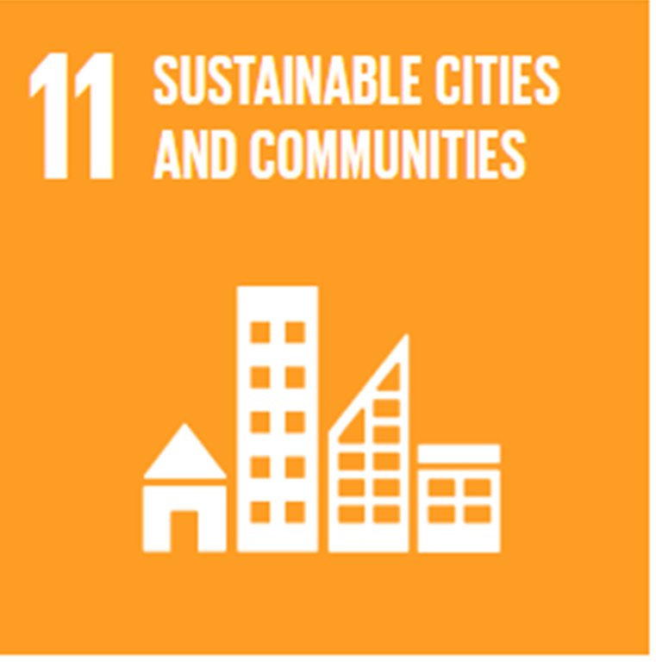
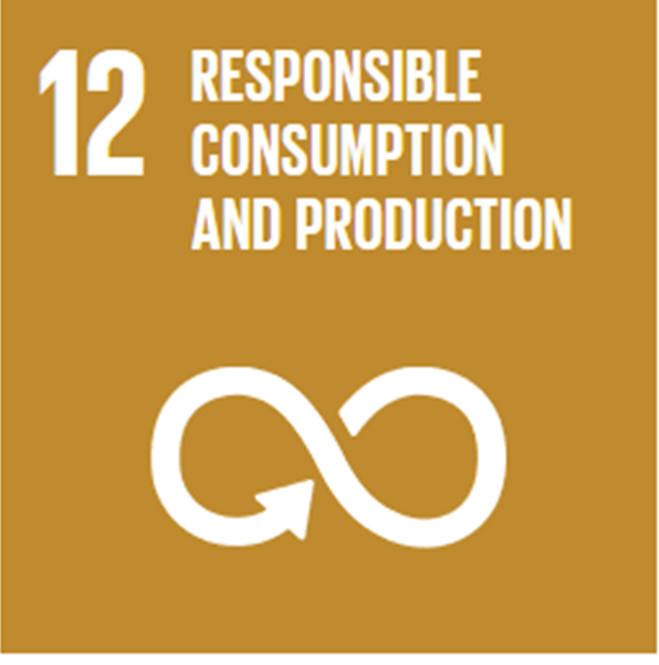
Global Goals


33-35 Heol yr Eglwys Gadeiriol, Caerdydd, CF11 9HB | 33-35 Cathedral Rd, Cardiff, CF11 9HB
029 2025 6767 keepwalestidy.cymru info@keepwalestidy.cymru
Cadwch Gymru’n Daclus yn gwmni wedi ei gyfyngu trwy warant. Rhif Cwmni: 4011164 Rhif Elusen: 1082058 Rhif TAW: 850 3958 13
Keep Wales Tidy is a Company Limited by Guarantee. Company Registration Number: 4011164 Charity Registration Number: 1082058 VAT Registration Number: 850 3958 13


