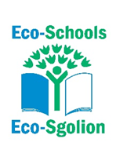
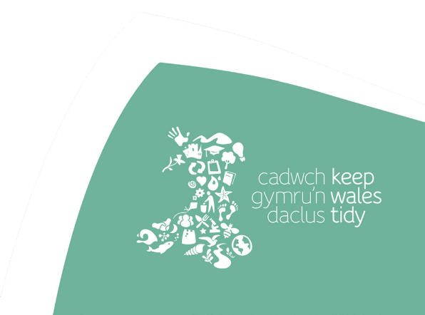

Awesome Artists and Super Scientists


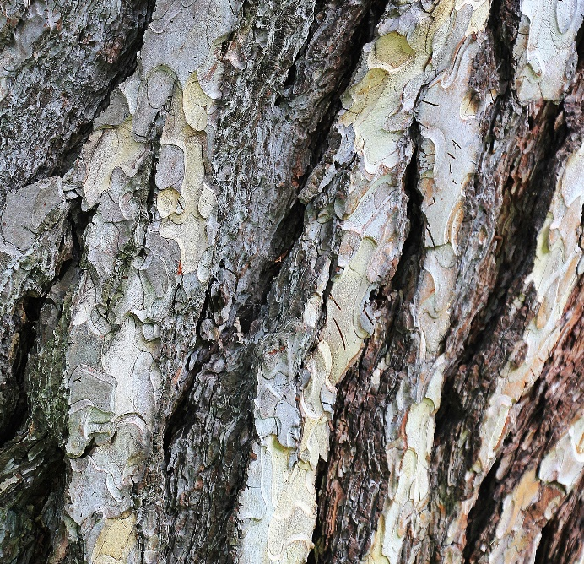
Awesome Artists
Activity: Bark Textures
Time: 15 minutes

Global Goals:
Global Goal 3 – Good Health and Well Being
Global Goal 15 – Life on Land

Aim: To appreciate the different textures of tree bark and understand that bark can be one of the tools used
to identify tree species in winter
Resources: Plain Paper or light coloured sugar paper
Charcoal/wax crayons/pencils
Folder to keep completed bark rubbings in

Background information:
The first thing you notice about a tree is its leaves.
It is the easiest aspect to look at when trying to determine an oak tree from an ash tree.
One difficulty, if it is a native broadleaf tree in winter, there are no leaves! So, another strategy is to look at the tree bark. Look carefully and you will be stunned by different colours and textures. It could be a tree with deep ridges and furrows like an oak tree. Compare that to the smooth grey bark of a beech tree.
Not only will a bark rubbing be a work of art in its own right, but close inspection of it will also help with tree identification.

Activity:
- Find a tree in the school grounds with interesting bark.
- Take your sheet of paper and press it against the bark of the tree.
- Take your charcoal/wax crayon/pencil and rub it against the paper, applying gentle pressure.
- Once you have filled the paper and you feel your bark rubbing is bold enough remove the paper and look carefully at the patterns.
- Repeat the process on several, different trees. Which is your favourite? Why? How do they differ?
- Experiment with different colours and hand the bark rubbings to the scientists to use for tree i.d. or have a go yourself.

Curriculum Links Purposes:
• Ethical, informed citizens of Wales and the world.
AOLE’s
• Science and Technology
What matters statements:
• The world around us is full of living things which depend on each other for survival.
AOLE’s
• Expressive Arts
What matters statements:
• Creating combines skills and knowledge drawing on the senses, inspiration and imagination.

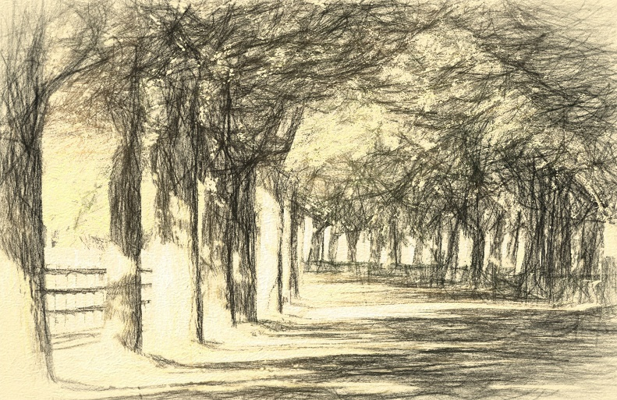
Awesome Artists
Activity: Landscape Artists – Capturing the Beauty of Trees
Time: 30 minutes
Global Goals: Global Goal 3 – Good Health and Well Being
Global Goal 15 – Life on Land

Aim: To explore the different shapes of tree and to appreciate their beauty and the positive impact they have on our landscape.
Resources: Plain Paper or light-coloured sugar paper
Charcoal/graphic pens/pencils
Clipboards
Folder to keep completed pictures in
I-pads
Background information
Observational art related to trees can be a great way to explore the basic tree shapes that help in identifying trees. Since all trees are individuals, naming tree shapes is not an exact science, but they can be split into the following broad groups:
- Round/Oval Shaped Trees – Often dense foliage e.g. Field Maple/Ash
- Columnar Shaped Trees – Tall and thin e.g. Lombardy Poplar
- Spreading Shaped Trees – Open and irregular shape e.g. Wild Cherry
- Weeping Shaped Trees – Long branches hanging down e.g. Weeping Willow
- Pyramidal Shaped Trees – Wider at the bottom e.g. Western Red Cedar
Sitting and drawing trees/landscape can be amazing for reducing stress and anxiety. It has been well researched that the exposure to nature is good for well-being and much of this research has been done in woodland. And you will be in good artistic company painting/drawing trees. Painters like Monet, Van Gogh, Turner and Constable have all dabbled! Why not research some of their famous landscape paintings

Activity:
- Find a comfortable space to sit back and take time to observe the tree you are going to sketch.
- Decide on the general shape of the tree. Is it Round, pyramidal or weeping? Sketch the general shape filling most of the paper.
- Look for shapes within the tree and note where the sun is casting light on the tree. Add those irregular shapes to your general shape.
- Add your trunk.
- Add dark tones, shade the areas furthest from the sun, keep it rough and irregular.
- Add the mid tones and then the light tones closest to the side the sun is casting it’s light.
- Finish off by shading the trunk with dark, mid, light tones following the same principles relating to the light as above.
- Why not try taking some photographs of the tree using the i-pad. What about adding some visual affects – sepia/black + white/pop art etc.
Curriculum Links Purposes:
• Ethical, informed citizens of Wales and the world.
AOLE’s
• Expressive Arts
What matters statements:
• Creating combines skills and knowledge drawing on the senses, inspiration and imagination.
AOLE’s
• Science and Technology
What matters statements:
• The world around us is full of living things which depend on each other for survival.

Awesome Artists
Activity: Tree Poet
Time: 30 minutes
Global Goals: Global Goal 3 – Good Health and Well Being
Global Goal 15 – Life on Land
Aim: To appreciate the beauty and uniqueness of the trees within the school grounds and represent this through the written/spoken word
Resources: Plain Paper
Pens/Pencils
Clipboards
Folder to keep completed poems in
Tree word bank resource sheet if required.

Background Information
Trees are incredibly long living. There are over 70 different types of tree living in the U.K. Oaks, one of the trees you have planted can be ancient. The oldest oak in the U.K. is perhaps the Bow Thorpe Oak in Lincolnshire with an estimated age of 1000 years.
We are inextricably connected to trees. Our well-being is linked to them, a fact we sometimes forget in the way we live our lives in the modern world. They provide our oxygen, clean our air, provide us with food and shade amongst many other benefits.
This activity gives an opportunity to develop an appreciation and connection to the trees in the school grounds and hopefully a desire to care for them.

Activity
- The outcome of this activity is to produce a team poem about a specific tree and recite it.
- In groups of 6 position pupils around a tree in the school grounds.
- Possibilities for positions could include – lying at the base of the tree looking up towards the canopy/looking at the tree from a distance/looking at a specific gnarly branch/hugging and smelling the tree/looking at the roots. You get the idea, anywhere that will generate different perspectives.
- Challenge the pupils to become word collectors relating to what they see, hear and feel. Leave them for as long as possible to generate these words. 5 minutes is a solid amount of time. Encourage figurative language as well.
- Come together to record the words on paper.
- Challenge them to now become wordsmiths and create a short poem using the words collected. Use the word bank sheet if required.
- Once the poem has been created and practiced share through performance.

Curriculum Links Purposes:
• Ethical, informed citizens of Wales and the world.
AOLE’s
• Languages, Literacy and Communication
What matters statements:
• Expressing ourselves through languages is key to communication.
AOLE’s
• Expressive Arts
What matters statements:
• Creating combines skills and knowledge drawing on the senses, inspiration and imagination.
AOLE’s
• Science and Technology
What matters statements:
• The world around us is full of living things which depend on each other for survival.


Super Scientists
Activity: Wildlife Explorer
Time: 30 minutes
Global Goals:
Global Goal 11 Sustainable Cities and Communities
Global Goal 15 Life on Land

Aim: Explore the different habitats and animals living on your school grounds
Resources:
RSPB ID sheet
Clipboard
Pens/Pencils
Map/satellite image of school
Helpful:
magnifying glass, bug pots, white sheets/scrap paper, soft brush

Background information
Did you know there are over 25,000 minibeast species living in the UK?
Minibeasts can be found living in lots of different places. In leaf piles, in the soil, under rocks stones and other objects, in trees, pond and hedgerows to name just a few! Minibeasts are small creatures like worms, snails, spiders and insects. The scientific name for these creatures is invertebrates, creatures without a backbone.
Minibeasts are crucial for survival and are an important part of our ecosystem. Planting trees will encourage new and wider varieties of animals to your school. The Oak tree is a particularly good habitat for your forest, Oaks provide a habitat for more organisms than any other tree species in the UK! A single oak tree can provide a habitat for 350 different species of insects, which is great as a food source for birds!

Activity:
- Familiarise yourself with the RSPB minibeast identification sheets here
- In groups of 3/4 pick an area of your school grounds to investigate. Think about exploring different areas or habitats.
- Explore the area and identify as many minibeasts as possible. Keep a tally of all you find.
- Return to the class and discuss the following;
- What is the most common minibeast in your school?
- What part of the school grounds is home to the most minibeast? Why?
- What can we do to protect their habitats and encourage more wildlife to the school grounds?
- Using a satellite image of your school and grounds add images of all the minibeast you found and their location to create a map of habitats.
Curriculum Links Purposes:
- Ethical, informed citizens of Wales and the world
AOLE’s
- Science and Technology
Statements of what matters
- The world around us is full of living things which depend on each other for survival.
AOLE’S
- Humanities
Statements of what matters
- Our natural world is diverse and dynamic, influenced by proceeded and human actions.

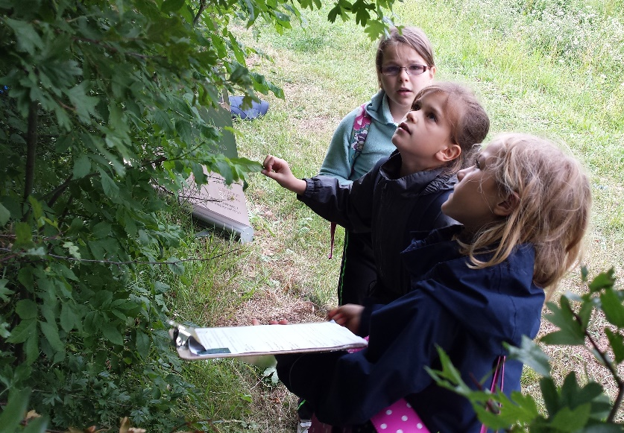
Super Scientist
Activity: Tree Detective
Time: 30 minutes
Global Goals:
Global Goal 11 Sustainable Cities and Communities
Global Goal 15 Life on Land

Aim: To understand the importance of tree identification and identify tree species at different times of the year.
Resources
Woodland Trust ID sheet
Choose the most appropriate sheet for the time of year.
Pens
Pencils
Map/satellite image of the school

Background Information
Did you know, there are 60,000 different species of trees in the world? 60 of those are native to Britain.
Native trees are important because they have adapted to grow in our climate and harbour far more wildlife than non-native species. Unfortunately, half of Britain’s ancient woodlands have disappeared since the 1950s although we have seen an increase in woodland cover in Wales since the 1900s.
Trees provide shade, habitats for animals, oxygen and resources for humans. Knowing how to identify trees and knowing our Oak from our Elder can help us look after and care for these important commodities.

Activity
- Using the map/satellite image of your school ground walk the school grounds and mark the location of all the trees you find.
- Using this Identification sheet try and identify each of the species on your map.
- Label your map with the identified tree species. You could do this with images or by creating a colour coded key for your map.
- Return to your class, were there any tree species you were unable to identify? Use your detective skills to investigate online what tree species they might be and add them to your map.
Curriculum Links Purposes:
- Ethical, informed citizens of Wales and the world
AOLE’s
- Science and Technology
Statements of what matters
- The world around us is full of living things which depend on each other for survival
AOLE’S
- Humanities
Statements of what matters
- Our natural world is diverse and dynamic, influenced by proceeded and human actions.

Super Scientist
Activity - Trees and your Carbon footprint
Time: 30 - 45 minutes
Global Goals: Global Goal 13 Climate Action
Global Goal 15 Life on Land
Aim: Understand the role that trees have in absorbing CO2 from our atmosphere.
Resources
Pens
Calculator
Scrap paper
Natural Resources Wales Carbon footprint sheet and resources card

Background Information
Trees play a vital part in reducing the amount of carbon dioxide in our atmosphere reducing the effects of global warming. As trees grow, they absorb CO2 and release oxygen. As trees grow, they will continue to store the carbon in the wood.

Activity
- Using Natural Resources Wales Carbon footprint sheet and resources card complete the table in step 1 to work out your total carbon emissions for 1 year. Use the estimates of 1 member of your group.
- Continue with steps 2 and on the resource sheet and work out the circumference of the tree that equates to your annual carbon footprint.
- Visit your school grounds, are there any trees on your school grounds big enough in circumference to absorb your yearly carbon footprint?

Curriculum Links Purposes:
- Ethical, informed citizens of Wales and the world
AOLE’s
- Science and Technology
Statements of what matters
- The world around us is full of living things which depend on each other for survival
AOLE’S
- Mathematics and Numeracy
Statements of what matters
- The number system is used to represent and compare relationships between numbers and quantities.



33-35 Heol yr Eglwys Gadeiriol, Caerdydd, CF11 9HB | 33-35 Cathedral Rd, Cardiff, CF11 9HB
029 2025 6767 keepwalestidy.cymru info@keepwalestidy.cymru
Cadwch Gymru’n Daclus yn gwmni wedi ei gyfyngu trwy warant. Rhif Cwmni: 4011164 Rhif Elusen: 1082058 Rhif TAW: 850 3958 13
Keep Wales Tidy is a Company Limited by Guarantee. Company Registration Number: 4011164 Charity Registration Number: 1082058 VAT Registration Number: 850 3958 13

